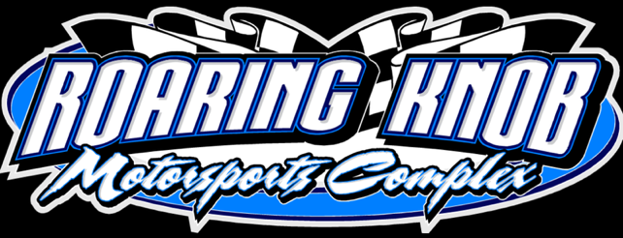

Roaring Knob Motorsports Complex

2025 Race Season Point Rules

Points will be update by Monday of the weekend raced. If it is not, I will post an update via Facebook. For any questions or concerns, please reach out to Katie Jones (410) 596 – 6431.

Feature Results:

1. 60
2. 55
3. 50
4. 45
5. 43
6. 41
7. 39
8. 37
9. 35
10. 33
11. 31
12. 29
13. 27
14. 25
15. 23
16. 22
17. 21
18. 20
19. 20
20. 20

DNS – 10

Heat Results:

1. 10
2. 5
3. 3
4. 2
5. 1