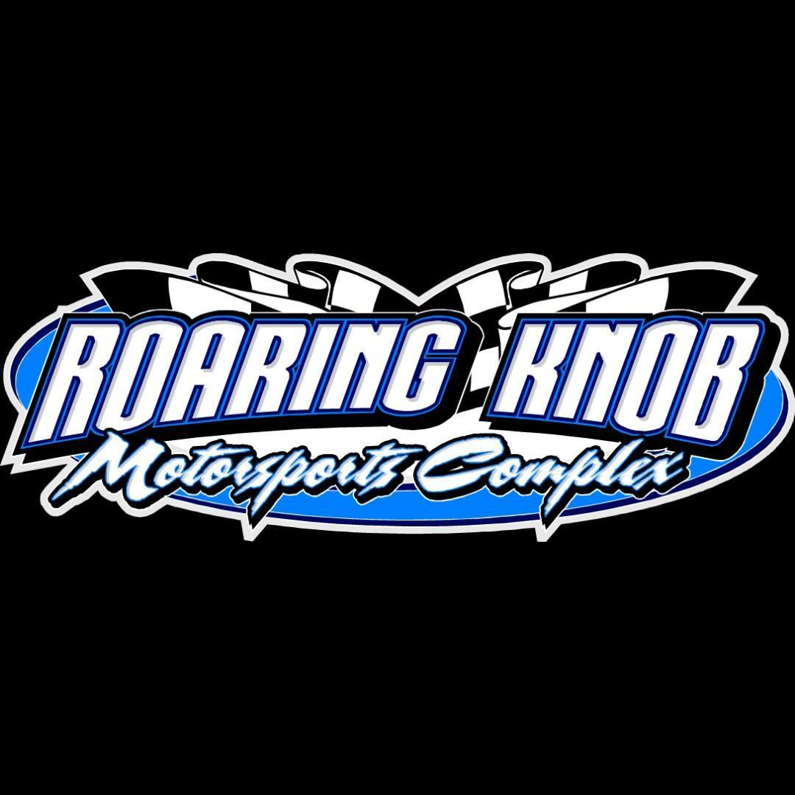

**2025 FOUR CYLINDER RULES:**

FWDs will run under SCDRA rules except for a few highlighted changes

BASICS:

1. Must be a stock 4-cylinder car
2. No turbo or rotary engines allowed
3. Stock-type fuel injection or stock manufactured carburetor only (Motorcraft, etc...).
   1. ONE 0.800" maximum throttle body spacer may be used. No Holley, Weber or other racing carburetors allowed. Carburetor must be stock for engine.
4. Motor must be stock appearing and in stock location
5. Motor must match car (ex. Honda must have Honda engine)
6. Any air or oil filters (K&N, etc.)
7. Intake must be a stock intake. No Skunk 2, etc.
8. No cold air intakes for fuel injections – must be stock type breather system. A flexible rubber or plastic hose may be used in place of the stock air box tube. No smooth metal or smooth plastic tubing allowed. A cone type filter is allowed and may be connected directly to throttle body or the allowed tubes.
9. Stock Fuel tanks may be left in original position BUT MUST have a skid plate underneath for safety NO EXCEPTIONS
10. Aftermarket radiators okay – radiators can be braced for support
11. Aftermarket (racing) headers are allowed. ***No claim Rule
12. Computer may be chipped and/or tuned. A standalone ECU and aftermarket harness are allowed. Ignition coil must remain OEM

WEIGHT RULES:

1. All cars must weigh 2,200 pounds with car and driver after the race Exceptions: 50 lb. weight break for HANS or like device 50 lb. weight break for containment seat 3.

BODY / WHEEL / TIRE RULES:

1. Any front wheel drive car
2. No all-wheel drive cars or all wheel steer cars
3. Must have stock rear and front suspensions as from factory, Slotting of factory mounting holes allowed.
4. No racing springs (lowering) or shocks allowed. Springs may be heated, clamped or use spring rubbers. Springs must be within 2’ of factory installed height
5. Rear control arms should be stock but may be braced / strengthened / repaired. No aftermarket.
6. Stock type aftermarket suspension bushings are allowed
7. Stock production cars only *ABSOLUTELY NO MIRRORS ALLOWED
8. Must have a quality welded MINIMUM 4-point roll cage inside the car with a minimum of 0.95" thickness tubing –
   1. *Roaring Knob Motorsports Complex Tech has final say in safety of the cage
9. Minimum 3 driver door bars / 2 side door bars – 6 or more-point cages okay
10. No push bars past firewall. Roll cage may extend forward behind bumpers. Bumpers must be covered in some way with no exposed sharp corners
11. Aftermarket racing wheels allowed – 7 inch maximum. NO BEAD LOCKS
12. Street legal DOT tires required. No drag radials, mud grip lug tires, racing tires or racing recapped tires allowed. Directional tires are allowed. - Tires can be mixed and matched for stagger
13. Aftermarket nose pieces allowed.
14. 6-inch metal support to extend out behind nosepiece or to hold grill in place allowed
15. No push bars to extend outside of bumpers or beyond nose piece.
16. Some sheet metal will be allowed for repairs. Cars should remain as close to stock appearing as possible. Adding sheet metal to bodies may result in a weight penalty being assessed.
17. Gutting of body is allowed.

SAFETY:

1. Window nets are MANDATORY. ABSOLUTELY NO Sprint Style nets are permitted.
2. RACING (not motorcycle) helmet, SA 2005 or newer is required.
3. Minimum single-layer fire suit required (SA 3.2A specification recommended).
4. Fireproof gloves strongly recommended (SFI 3.3 specification recommended).
5. A 4- or 5-point harness, properly mounted per manufacturers’ specifications, is required.
   1. *Must meet manufactured expiration date. Any worn, abraded or torn belts shall be replaced.
6. A minimum 5 lb. fire extinguisher is recommended and should be securely mounted within drivers reach.
7. Only racing-type seats, properly mounted per manufacturers’ specifications, are allowed. A full containment seat is strongly recommended. Cars equipped with full containment seats will receive a 50 lbs. weight break.
8. A head and neck restraint system (SFI 16.1 compliant) is strongly recommended. Drivers using a head and neck restraint will receive a 50 lbs. weight reduction.
9. A firewall must be in place between driver compartment and fuel cells, fuel lines or tanks.

MISCELLANEOUS RULES:

1. Roaring Knob Motorsports Complex Tech has final ruling on all questions of legality. A pre-race inspection will be made to ensure SAFETY only.
2. Cars MUST be able to pass Pre-Race Inspection as well as Post-Inspection NO exceptions.
3. Competitors must present cars for inspection prior to participating in any racing event.
4. ABSOLUTELY NO radios allowed
5. RACEceivers or a like device is mandatory at all times on track