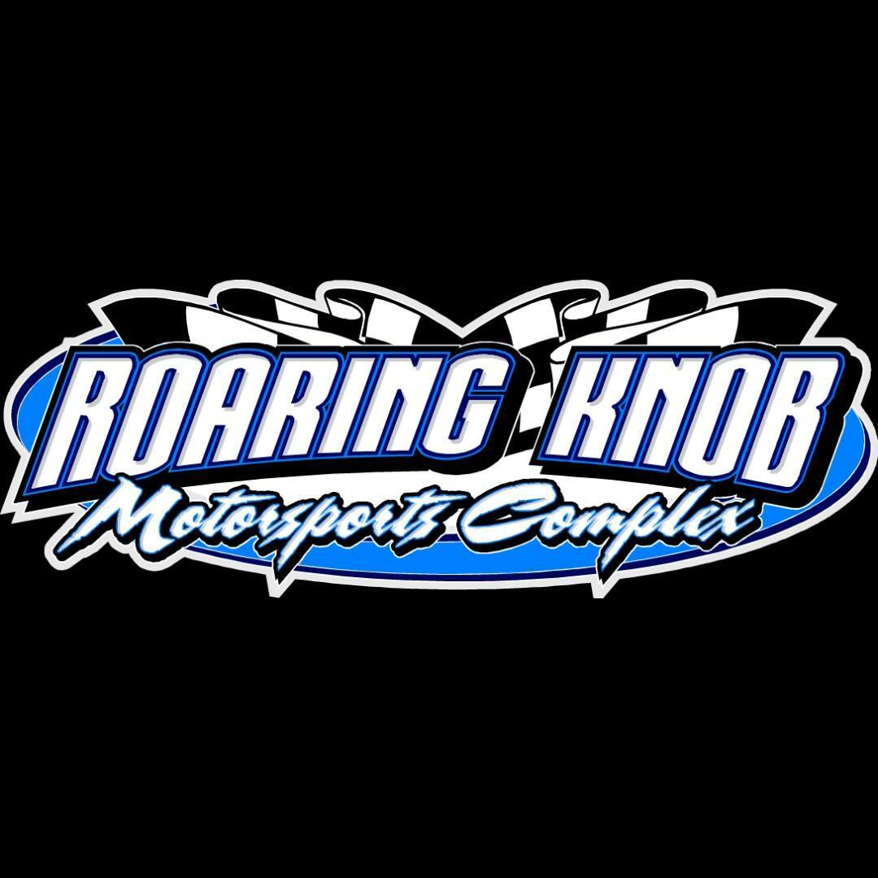

**2025 Enduro Rules:**

General Rules:

1. Off road racing is a hazardous sport, and with participation being completely voluntary. NO entrant, pit crew member or vehicle sponsor shall have any claim for damages, expenses, lawsuits, or otherwise against promoter, track owner, or track officials of Roaring Knob Motorsports Complex arising from damage to any vehicle, personal injury or death, monetary loss of any kind whatsoever.
2. Entrants, pit crew members, or vehicle sponsors who voluntarily participate in any racing activity conducted under these rules waive any claim they may have against the promoter, track owner, and track officials of Roaring Knob Motorsports Complex.
3. Supplementary regulations may be issued for each event necessary to amend, suspend, or modify existing rules and regulations.
4. All entrants must have a driver registration form filled out prior to the event. Drivers may be 14 yrs old and up. No driver 14-17 will be allowed to run without a signed waiver by a parent. Waivers can be gotten from the registration building and must be turned back in prior to the race starting.
5. Any entrant or crew member believed to be under the influence or caught consuming alcohol in the pits will lead to disqualification of the entrant for the entire night and you will be asked to leave.
6. Roof sign with number or number on driver’s side and passenger side door (must be big enough to be seen from the scoring tower) are required.

Vehicles:

1. 4 or 6 cyl CARS ONLY No exceptions
2. No V8, SUV, Van, or Trucks permitted.
3. No full frame cars, convertibles, or all-wheel drive cars allowed. *However, all-wheel drive cars may remove front or rear driveshaft and be permitted to run.
4. All cars must have stock engine or stock replacement and must be in factory stock location and mounts. *NO racing engines*
5. Tires MUST be DOT Legal Tires *Absolutely No winter tread, studded, all terrain, mud, gumball, racing, skid, or DOT stamp racing tire* All 4 tires MUST be the same size.
6. Original or stock replacement exhaust system only *NO aftermarket headers*
7. Stock transmission and rear end ONLY. *NO aftermarket external transmission coolers*
8. One radiator permitted and must be in original location *NO coolant or gas lines permitted inside the car*
9. NO locker rears allowed *If car is rear wheel drive you MUST have a drive shaft loop bolted or welded to the car*
10. NO aftermarket external oil coolers permitted
11. A/C and heat components as well as smog equipment may be removed
12. Catalytic converters are allowed to be removed
13. Car MUST arrive at track race ready.
14. Pit Stalls MUST be cleaned up at the end of the night and be free of any metal or glass. Your car MUST go home with you at the end of the Night. There are other events held at Roaring Knob Motorsports Complex, and we appreciate the help in keeping the pits clean for the next event.
15. Drivers will draw a pill for their starting position for the race. If you choose not to or you are not in the lineup area when need be then you will put to the rear of the field.
16. During Red Flag conditions ALL cars MUST come to a complete stop or making an attempt to advance positions under Red will result in immediate disqualification.
17. Cars will be removed from the track once the race is over DO NOT exit your car under green
18. Any gas leak on your car will result in stopping the race due to safety reasons and you will be scored as your final spot when/if your car is found unsafe to continue.
19. All prerace inspections are for your safety and any cars finishing in top 5 are subject to postrace inspection
20. All decisions made by the track officials are considered FINAL
21. There will be absolutely NO fighting of any kind. If any entrant, pit crew member, or vehicle sponsor is fighting with track officials or anyone else on the premises, or if any entrant, pit crew member, or vehicle sponsor is arguing with track officials could lead to disqualification of the entire night, loss of points, loss of payout and/or you may be suspended from the track*

Car Preparation:

1. Entire inside of car MUST be stripped of ALL plastic, carpet with exception of driver’s seat and dash
2. Entire outside of car MUST be stripped of glass, head lights, and plastic as well as any metal or plastic trim
3. All bumper covers MUST be removed
4. All plastic or fiberglass header panel MUST be removed
5. All windshields MUST be removed and MUST be replaced with heavy screen
6. Battery may be in original location *If moved it must be securely fastened and covered with a piece of rubber*
7. All airbags MUST be completely removed or cut out with covers off so tech can inspect
8. Roll cage is optional but HIGHLY recommended *Driver’s side door protection is Required. For example: steal plate, guard rail, c-Shannel, tubing, etc.*
9. Driver’s door protection MUST extend 4” past the front door and MUST have all sharp or blunt edges tapered to the body of the car
10. Some type of padding on the inside of the driver’s side door is Required
11. All doors MJST be welded or chained shut
12. NO bracing in bumper area is permitted *All bumpers MUST have a chain attached to each side and attached to car to prevent the bumper from falling off the vehicle
13. All sunroofs MUST be removed and covered with metal or a heavy screen
14. Working window net is REQUIRED on driver’s side window *DO NOT screen driver’s side window or weld bars over driver’s side window*
15. All stock steel unaltered floor panels, firewalls, trunk, and wheel wells MUST be retained
16. Cars MUST retain stock appearance *NO cutting, chopping, channeling, or shortening permitted*
17. Hoods MUST remain chained shut
18. Gas tanks MUST be in original, and stock location *If gas tank area is rusted through you may use a fuel cell in its place. Fuel cell MUST be located in the trunk area and MUST be securely fastened*
19. All holes in the rear firewall and speaker deck MUST be completely closed with sheet metal
20. Suspension MUST remain factory stock *NO cutting or altering*
21. Wheels MUST be stock steel or original aluminum only and MUST remove all wheel weights
22. Absolutely NO additional weight may be added to the car
23. Car MUST be clear of all debris

Driver Safety:

1. Full face helmets and eye protection are MANDATORY
2. Fire retardant jackets, suits and gloves are highly recommended but NOT required
3. One fire extinguisher per car is Required and be securely fastened to the floor
4. MUST have a working seatbelt *Approved shoulder harness and lap belts are recommended but NOT required*
5. Racing seats ARE permitted