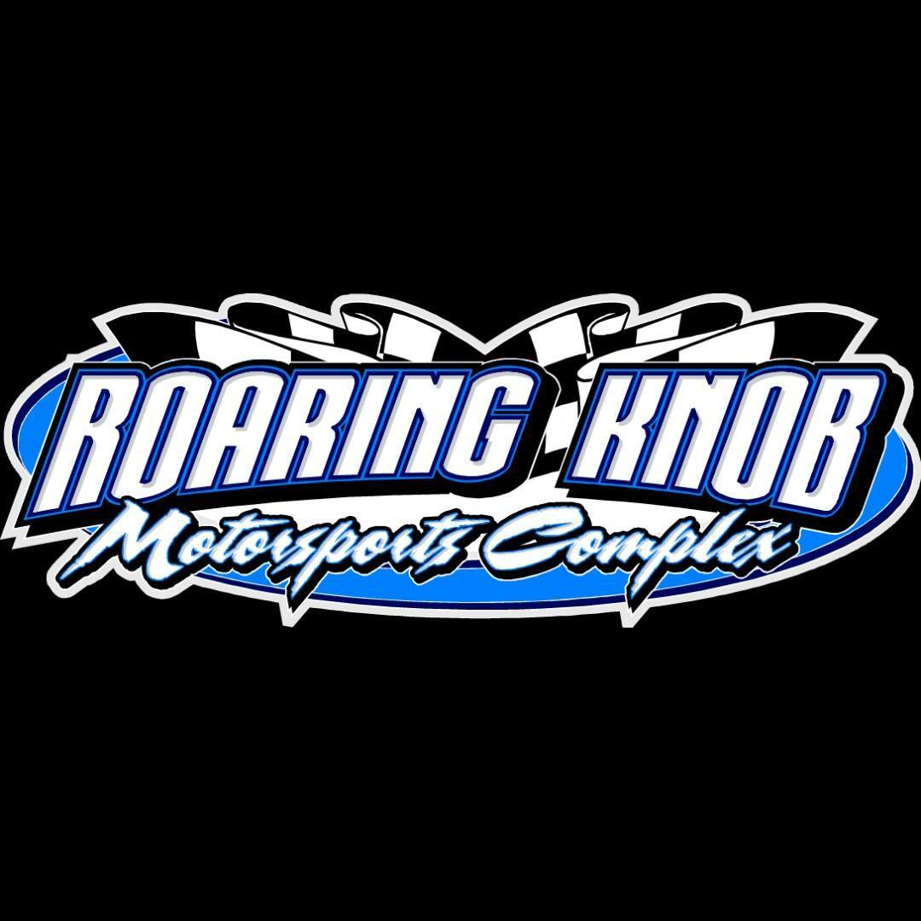

**Roaring Knob Complex Feature Finishes**

**August 8th, 2025**

Crate Late:

1. 90J – Michael Duritsky
2. 151 – Kolbe Kimbrew
3. 67 – Greg Carrico
4. 3 – Stanley Spooner
5. 44 – Bubby Tharp
6. 99 – Bob Gorden
7. 28 N – Noah Whited
8. 118 – Quintin Wyandt
9. 5 – Payton Dalton
10. 68 X – Ronald Pyles
11. 19 – Nick Niemiec

UMP Modifieds:

1. 29 – Scott Bittinger
2. D2 – Nolan Dalton
3. 44 – Sam Reeder
4. 54 – Roger Hirko
5. 21 – Dusty Swecker
6. 3JR – Mark Baier
7. 66C – DNS – Jacob Marker

Sport Modifieds:

1. 21T – Cole Tasker
2. 50 – Charlie Powers
3. 56C – Colton Pugh
4. 3 – Andy Spooner
5. T4- Travis Lueckertt

Chargers:

1. 62 – Andy Higinbotham
2. 06 – John Cain

4 Cylinders:

1. 12 – Jason Platter
2. 03 – Mike Thomas